図名・表名一覧

Fig. 1 Sample of figure 1 〔出典：文献1) 〕
Fig. 2 Sample of figure 2

Table 1 Sample of table

図

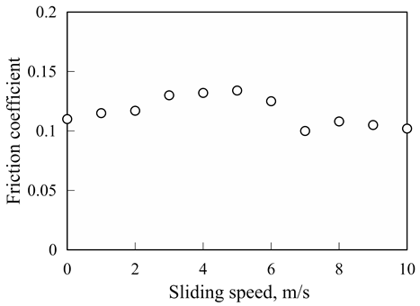
Fig. 1

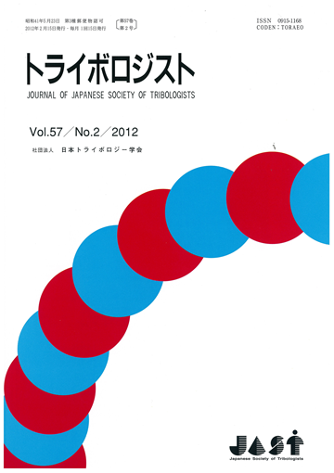
Fig. 2
表

Table 1
 | Test 1 | Test 2 | Test 3 | Test 4 | Test 5 | Test 6
Load, N | 1.0 | 1.0 | 1.0 | 2.0 | 2.0 | 2.0
Sliding speed, m/s | 1.0 | 2.0 | 2.0 | 1.0 | 2.0 | 2.0
Viscosity, mPa∙s | 5.0 | 5.0 | 10.0 | 5.0 | 5.0 | 10.0

